**Log Analytics With Deep Learning And Machine Learning**

by **Jagreet** | April 28, 2017 |  Categories -  [Log Analytics,](https://www.xenonstack.com/blog/category/Log-Analytics) [Machine Learning,](https://www.xenonstack.com/blog/category/Machine-Learning) [Deep Learning](https://www.xenonstack.com/blog/category/Deep-Learning)

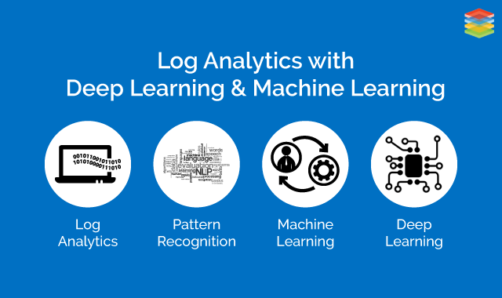

Deep Learning

Deep Learning is a type of Neural Network Algorithm that takes metadata as an input and process the data through a number of layers of the non-linear transformation of the input data to compute the output.

This algorithm has a unique feature i.e. automatic feature extraction. This means that this algorithm automatically grasps the relevant features required for the solution of the problem.

This reduces the burden on the programmer to select the features explicitly. This can be used to solve supervised, unsupervised or semi-supervised type of problems.

In Deep Learning Neural Network, each hidden layer is responsible for training the unique set of features based on the output of the previous layer. As the number of hidden layers increases, the complexity and abstraction of data also increase.

It forms a hierarchy from low-level features to high-level features. With this, it becomes possible that Deep Learning Algorithm can be used to solve higher complex problems consisting of a large number of non-linear transformational layers.

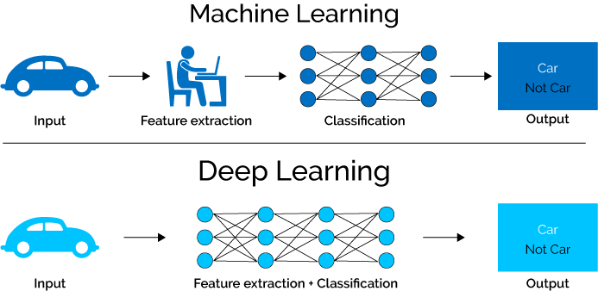

Machine Learning

Machine Learning is a set of the technique used for the processing of large data by developing algorithms and set of rules to deliver the required results to the user. It is the technique used for developing automated machines on the basis of execution of algorithms and set of defined rules.

In Machine Learning data is fed and set of rules are executed by the algorithm. Therefore, techniques of Machine Learning can be categorized as instructions that are executed and learned automatically to produce optimum results.

It is performed without any human interference. It automatically turns the data into patterns and goes deep inside the system for the detection of production problem automatically.

Why is Deep Learning called Deep?

The traditional neural network consists of at most 2 layers and this type of structure of the neural network is not suitable for the computation of larger networks. Therefore, a neural network having more than 10 or even 100 layers are introduced.

This type of structure is meant for Deep Learning. In this, a stack of the layer of neurons is developed. The lowest layer in the stack is responsible for the collection of raw data such as images, videos, text, etc.

Each neuron of the lowest layer will store the information and pass the information further to the next layer of neurons and so on. As the information flows within the neurons of layers hidden information of the data is extracted.

So, we can conclude that as the data moves from lowest layer to highest layer (moving deep inside the neural network) more abstracted information is collected.

**You May Also Like -** [Overview of Artificial Intelligence and Role of Natural Language Processing (NLP) in Big Data](https://www.xenonstack.com/blog/overview-of-artificial-intelligence-and-role-of-natural-language-processing-in-big-data)

Classes of Deep Learning Networks

* **Deep Learning for Unsupervised Learning:** This type of deep learning is used when labels of the target variable are not provided and higher correlation has to be computed from observed units for pattern analysis.

* **Hybrid Deep Networks:**In this approach, the goal can be accomplished either by using supervised learning for performing pattern analysis or by using unsupervised learning.

Why are a Large Number of Hidden Layers Used in Deep Learning?

Deep Learning works on the basis of the architecture of the network and the optimum procedure used by the architecture. The type of network followed is known as a Directed graph. The graph is designed in such a way that each hidden layer is connected with every hidden node.

So, combination and recombination of outputs from all units of hidden layer are performed in the context of the combination of their activation functions. This procedure is known as Non-Linear Transformation. After that optimum procedure is applied to the network to produce optimum weights for each unit of a layer.

This is the whole routine for the flow of information inside the hidden layers to produce required target output.

Too many hidden layers present in the algorithm is not feasible. This is because the neural network is trained with the simple gradient descent procedure. If a huge number of hidden layers are involved in the algorithm, then this gradient descent will be reduced that further affects the output.

Difference Between Neural Network and Deep Learning Neural Network

Neural Network is a network that can use any network such as feedforward or recurrent network having 1 or 2 hidden layers. But, when the number of hidden layers increases i.e. more than 2 than that is known as Deep Learning Neural Network.

Neural Network is less complex and requires more information about features for performing feature selection and feature engineering method. On the other hand, Deep Learning Neural Network does not require any information about features rather they perform optimum model tuning and model selection on their own.

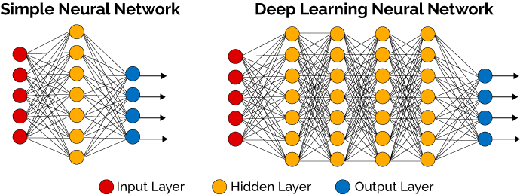

Why is Deep Learning Important Today?

In today’s generation usage of smartphones and chips have increased drastically. Therefore, more and more images, text, videos, and audios are created day by day. But, as we know that a single layer neural network can compute complex function.

On the contrary, for the computation of complex features deep learning is needed. This is because deep nets within the deep learning method have the ability to develop a complex hierarchy of concepts.

Another point is that when unsupervised data is collected and machine learning is executed on it, manually labeling of data has to be performed by the human being. This process is time-consuming and expensive. Therefore, to overcome this problem deep learning is introduced as they have the ability to identify the particular data.

Need of Deep Learning Neural Network

There are various methods that are introduced for the analysis of log file such as pattern recognition methods like K-N Algorithm, Support Vector Machine, Naive Bayes Algorithm etc. due to the presence of a large amount of log data, these traditional methods are not feasible to produce efficient results.

Deep Learning Neural Network shows excellent performance in analyzing the log data. It consists of excellent computational power and automatically extracts the features required for the solution of the problem. Deep learning is a subpart of Artificial Intelligence. It is a deeply layered learning process of the sensor areas in the brain.

Different Techniques of Deep Learning

Different techniques of Deep Learning are described below:

* **Convolutional Neural Networks: T**his is a type of network that constitutes of learning weight and biases. Every input layer is composed of a set of neurons where at every input a dot product is performed and move further with the concept of non-linearity. It is a kind of fully-connected type of network that uses SVM/Softmax function as a loss function.

* **Restricted Boltzmann Machine:**It is a kind of stochastic neural network that consists of one layer of visible units, one layer of hidden units and a bias unit. The architecture is developed in such a way that each visible unit is connected to all hidden units and bias units are connected to all visible and hidden units. During the learning process, the restriction is developed so that no visible unit is connected with any visible units and no hidden unit is connected with any hidden unit.

* **Recursive Neural Network:**It is the type of deep learning neural network that uses same weights recursively for performing structure prediction about the problem. The stochastic gradient is used for training the network using backpropagation algorithm.

Deep Learning Applications

* **Biological Analogs:**In the case of the artificial neural network the lowest layer can extract only basic features of the dataset. Therefore, the convolutional layer is used with the combination of pooling layers. This is performed to increase the robustness of features extraction. The highest convolutional layer is developed from the features of previous layers. These highest layers are responsible for the detection of highly complex features.

* **Image Classification**: To recognize the human face, first the edges are detected by the deep learning algorithm to form the first hidden layer. Then, by combining the edges together next shapes are generated as a second hidden layer. After that shapes are combined together to form the required human face. In this way, other objects can also be recognized.

* **Natural Language Processing**: Reviews of movies or videos are gathered together to train them using deep learning neural network for the evaluation of reviews of movies.

* **Automatic Text Generation**: In this case, a large recurrent neural network is used to train the text so that relationships between the sequence of strings could be determined. After learning the model the text is generated word by word/character by character.

* **Drug Discovery**: Deep learning neural network is trained on gene expression levels and scores of activations are used for the prediction of therapeutic use categories.

How is Deep Learning Used?

Deep learning neural network plays an important role in [knowledge discovery](https://www.xenonstack.com/blog/understanding-log-analytics-log-mining-anomaly-detection), knowledge application, and last but least knowledge-based prediction. Areas of usage of deep learning are listed below:

* Power image recognition and tagging
* Fraud Detection
* Customer recommendations
* Used for analyzing satellite images
* Financial marketing
* Stock market prediction and much more

Data Used for Deep Learning

Deep Learning can be applied to any type of data such as sound, video, text, time series, and images. The features needed within the data are described below:

* The data should be relevant according to the problem statement.
* In order to perform the proper classification, the dataset should be labeled. In other words, labels have to be applied to the raw dataset manually.
* Deep Learning accepts vectors as an input. Therefore, the input dataset should be in the form of vectors and same length. This process is known as [Data Processing](https://www.xenonstack.com/blog/ingestion-processing-data-for-big-data-iot-solutions).
* Data should be stored at one storage place such as file system, HDFS (Hadoop Distributed File System). If the data is stored in different locations which are not inter-related with each other then, data pipeline is needed. The development and processing of data pipeline is a time-consuming task.

How is Deep Learning Used for Log Analytics?

How deep learning can be used for the analysis of log data is explained with examples.

Suppose we have to analyze the server log to extract the information about the events performed by the internal employees and thus helps to interpret how much data is leaked from the organization's server.

There are many existing solutions for the security of data but the results produced by them are not up to mark. Therefore, administrator of the security department examines the flow of data by analyzing the server logs.

But, there is a drawback that the response time taken by the administrator is huge and efforts made for the detection of leakage of data is vain. Deep Learning provides best results in analyzing the server log files.

A system is proposed that uses Deep Learning Algorithm to examine the activities of the internal employees. First of all, the security log information is collected. This information consists of user's information documents, their personal information along with the user access rights.

It also consists of information regarding the leakage of data from the database. The data leakage procedure is defined by considering both the security log list and the purpose of the data leakage. After completion, a graph is developed using data leakage procedure.

This graph describes at what time the data is leaked and distinguish the personal information of each internal employee using different color palettes. After the graphical representation of data leakage, the deep learning is trained to classify the graphs into the normal and the abnormal behavior of internal employees.

Deep Learning Algorithm is implemented by using these graphs as an input and compare the similarity with the graph showing the data leakage by the internal employee. After receiving the information the administrator will examine the path of the data leakage.

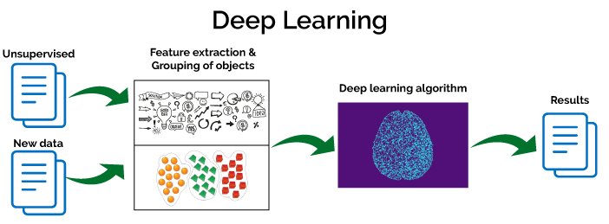

Now let's discuss another example about the analysis of log messages using deep learning algorithm. Log messages consist of messages in the form of text. Traditional algorithms like support vector machine etc do not produce optimum results while performing text classification.

This is because these methods are not able to determine the semantic relationship between the words. Therefore, deep learning algorithm known as a recurrent neural network is used for the log analysis.

The concept behind the recurrent neural network is that it consist of a hidden layer which acts as a memory that stores the internal state of the log data. When the new data arrived, the memory is updated and decisions are made according to the current and previous input.

The input layer will consist of log messages and training is performed with the algorithm, whenever the abnormal behavior is depicted by the hidden layer, an alert will be given. This is one of the best approaches for the analysis of log files.

Now let’s discuss how log analytics is performed in the [Big Data Platform](https://www.xenonstack.com/big-data-infrastructure-solutions) using Deep Learning. Firstly, all types of log data are taken as input such as proxy infrastructure log, DNS infrastructure log and much more. Data integration is performed by collecting all log data at one location.

There are various data integrated tools in Big Data platform such as [Apache Flume](https://flume.apache.org/), [Apache Nifi](https://nifi.apache.org/), and [Apache Kafka](https://kafka.apache.org/). After the data collection, next step is to store the log data into the storage system such as [HDFS (Hadoop Distributed File System)](https://hadoop.apache.org/docs/r1.2.1/hdfs_design.html), No-SQL Database like [Hbase](https://hbase.apache.org/) etc.

After storage, processing of the data is performed by the corresponding tool engine like [Apache Spark](http://spark.apache.org/), [MapReduce](https://hadoop.apache.org/docs/r1.2.1/mapred_tutorial.html) and much more. Then deep learning techniques are executed and patterns are identified as output.

The obtained output of Deep Learning in CSV format is stored in the storage system. While executing Deep Learning security use cases are also performed parallelly. After that, the output is visualized in the form of Graphical User Interface (GUI).

How is Machine Learning Applied for Log Analytics

The basic concept of Machine Learning usage for log analytics can be explained with an example. As shown in fig three types of inputs are obtained. First input sources are system counters, CPU, memory, disk, and network.

Now the second input source is a large amount of distributed logs from different applications around your system. Third input source is consist of error logs, crashing of executable programs, improper shutting down of applications etc.

After the collection of all these input sources, a relevant type of information from these logs is extracted automatically with the use of Bayesian Algorithm. Relevant logs are obtained as an output. Machine learning is used to aggregate the logs automatically into correlated categories. Then, newly log data will automatically incorporate into the corresponding category.

Let's take an example how machine learning can be used to detect system failure automatically. First, select the representation of features of log data and use them to fit the appropriate model according to the given dataset.

Training data is used to recognize the failure within the system. Now, evaluate the performance of the model using test dataset. This is the process of supervised learning i.e. log data patterns can be defined in advance.

On the contrary, if log data patterns cannot be defined in advance unsupervised learning is introduced. In this approach, most relevant patterns are taken without the need of training dataset provided by the human being.

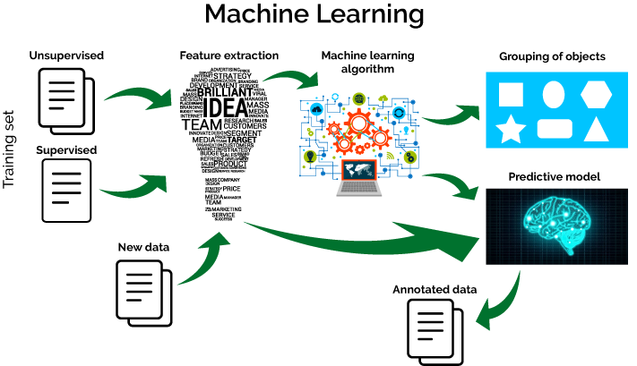

Summary

Both Machine Learning and Deep Learning can be used for Log Analytics but the selection of algorithm is based on the problem statement.

If the data consist of a large number of attributes and complex computation has to be performed then deep learning is the better option.

The importance of deep learning is growing day by day due to the advancements in the technology and increasing availability of digital data.